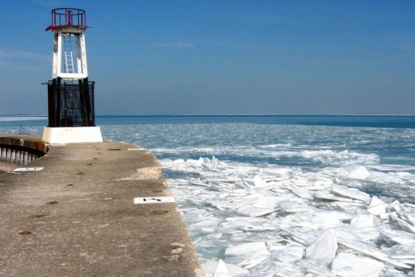

Climate Change
Climate change is first and foremost an issue because people can’t even agree on whether or not it’s an issue in the first place. Before we even get into the solutions, we all (regardless of political party) need to come to the realization that yes, climate change is real and yes, it is affecting us in ways that we can see and feel. If you still believe that the freakish weather and heat waves we’ve been experiencing have nothing to do with climate change, you might want to ask your neighbor what he or she thinks because the majority of Americans now say they believe global warming is causing these incidents.
You might have noticed that the weather’s been hotter than usual, or you might have noticed a drought in your area or conversely, unusual storms. Furthermore, even small temperature changes are causing crops to die, decreasing the amount of food available. On top of all that, higher temps are causing the polar icecaps to melt, flooding certain areas and leading to an imbalance for wildlife.
So we know the threat is real, but what can we do to prevent climate change from being exacerbated even more? Some small steps you can take in your own life are to use less electricity by turning off your lights when you don’t need them, driving less, switching to LED bulbs and eating less meat. On a more global scale, leaders are trying to come to an agreement on how to curb the harmful greenhouse gases each nation emits into the atmosphere, and steps are being taken to plant more forests (which act as natural carbon sinks). Every little bit helps, but in order for us to reverse the current course the Earth is on, we’ll need to come to an agreement that climate change is real and that it is a cause that we need to invest money and time in immediately.

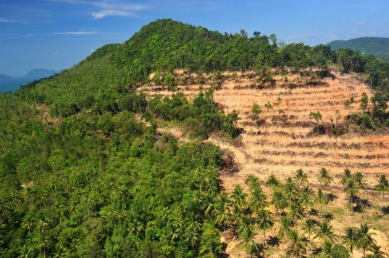Rainforest Destruction in Thailand Image from Shutterstock

Deforestation
We mentioned planting more forests above, and sadly at a time when we need more forests, trees are being uprooted at an alarming rate. Deforestation is a rapidly-growing problem in areas like Africa, Central and South America. Not only does this mean less trees, less cleansing oxygen, and the displacement of the wildlife, deforestation means a dangerous decrease in a natural fighter of global warming – the #1 threat to our Earth right now. Removing trees also leads to much drier climates, as trees extract groundwater to release into the air.
Our tropical rainforests, which are crucial to stabilizing the climate and to human survival, are being chopped down at a breakneck pace – one and a half acres of rainforest are lost every second. Humans have already chopped down about 50% of the rainforests that once existed on the planet and at the current rate of destruction, we will completely destroy the rainsforests in the next 40 years. If rainforests are so important, why are they being destroyed so carelessly? Short-sighted governments and multi-national logging companies only see the forests as a way to make money by selling timber – they don’t consider the long-term effects.
Luckily, deforestation is an issue that we as individuals can combat. By using recycled paper, we can decrease the need to cut down as many trees and by buying goods made with FSC-certified wood, we can show retailers that we don’t want them to support brands that obtain lumber irresponsibly. Last but not least, why not plant a tree or even a hundred trees like this man did.

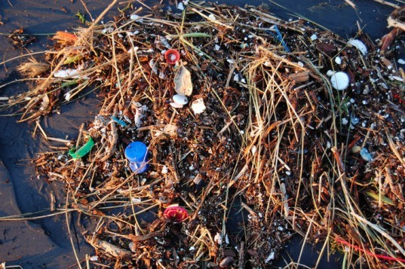©Kevin Krejci

Pollution
Pollution comes in many forms and no matter where you live, you’ve probably seen some form of it. From litter on NYC city streets to the smog that lingers over LA to the plastic trash that floats in the Great Pacific Garbage Patch, the visible signs of pollution are more than evident. The main reason for why pollution has gotten so out of control is that our desire for more “stuff” has led to our old stuff being thrown away at an alarming and unnecessary rate. For more information on this, watch Annie Leonard’s Story of Stuff. This need for manufactured items also leads to the air and water pollution emitted from factories, which in many countries are highly unregulated. Looking at the bigger picture, government oversight and sloppy industrial practices on the part of big companies has also exacerbated our pollution problem.
The first thing we can all do to reduce the amount of pollution in our streets, air and water is to make a mental change. Before buying a new product, ask yourself if you really need it or if you might be able to purchase it secondhand. It could make a big difference in the amount of trash we see in our landfills. Secondly, if you don’t already recycle, get into the habit. If everyone adopted these easy principles, the world would be in a much better place.

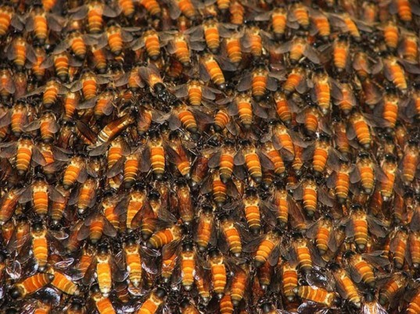©No Minds Vision

Loss of Biodiversity
Each species has a role in our planet, and when one dies out, it can have catastrophic effects on the rest of us. We don’t want to get all “Butterfly Effect” on you but even a population dwindling can cause major problems for the human race. For example, with their role of pollination, the decline of the bee population has a direct effect on both the environment and food production. Currently, many other animals are in danger of becoming extinct, either from being forced out of their habitats by man or by climate change.
This particular problem is more difficult for individuals to combat but we can start by educating ourselves with the facts and donating to organizations like the World Wildlife Fund that facilitate the preservation of animals on the brink of extinction. This problem is also closely linked to deforestation and unchecked habitat destruction so by fighting those two issues, we can also slow down loss of biodiversity.

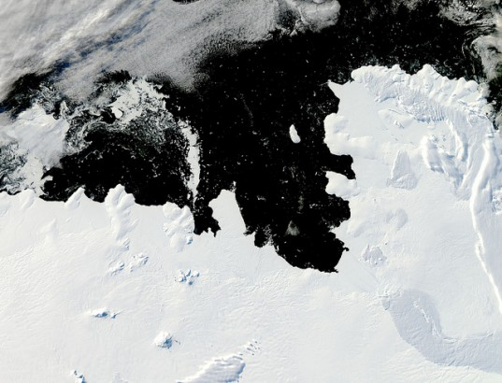

Melting Polar Ice-Caps and Rising Sea Levels
Climate change (are you seeing a trend here?) also contributes to another dangerous problem – melting polar ice-caps, which in turn causes rising sea levels. According to the NRCD, average temperatures in the Arctic region are rising twice as fast they are elsewhere and the ice is melting and rupturing. NASA satellite images reveal that the area of our permanent ice cover is shrinking at a rate of 9% every decade. At that rate, the Arctic could be totally ice-free in the summer season by the end of the century.
And if all of that ice melted, where would it go? You guessed it – our oceans. You might think that rising tides are only a problem for people in a few isolated areas, but major cities like NY and London could be underwater soon if we don’t do something soon. Manhattan alone has already dreamt up ways to deal with the potential rising tides over the next few years, but coming up with solutions after the fact is not enough. In order to reverse the melting of polar icecaps, we have to start at the root of the problem. See our section above on climate change to learn what you can do personally to keep global warming from continuing on its deadly course.

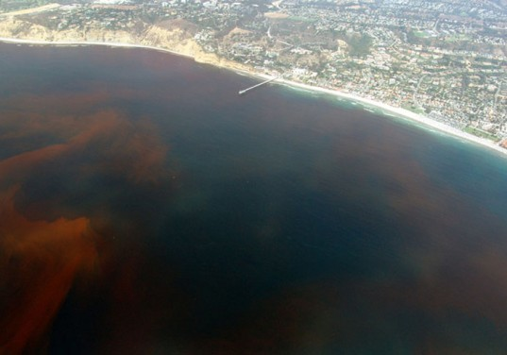

Oceanic Dead Zones
Along the coasts of heavily populated communities, scientists have found more and more dead zones– areas where depleted oxygen levels cannot support marine life. 146 dead zones were found in the world’s oceans, caused by high levels of chemicals in the waters. North America’s Gulf Coast has a high concentration of dead zones, which causes fish to become unable to reproduce. You might think that if you live on land, you won’t be affected by oceanic dead zones but if you eat seafood, seaweed, or care about air quality, you won’t want to ignore this issue.
The good news is that dead zones can be reversed, though it is difficult. The Black Sea dead zone disappeared in 1991 and 2001 due to the discontinued use of fertilizers. To find out more about how you can help with dead zone cleanups, visit Oceana.org.

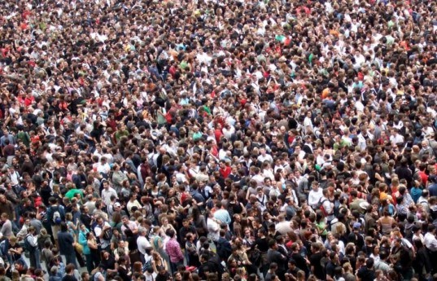©James Cridland

Explosive Population Growth
It’s usually true that the more the merrier, but not when the human population is growing to a point that our society and systems can’t handle. Last year, the world population hit a whopping 7 billion, and while we welcome the newcomers with open arms, we also want to make sure that we don’t continue to put a strain on our water, food, well-being, space and sanity (yes, we’re talking about you, Tokyo subway system).
If everyone were more conscious of the fact that our limited resources need to be shared (how many times have you grabbed a fistful of paper napkins when you only needed one?), we could make living together, even with such a large amount of people) a lot more pleasant. Another example is our world food supply. Statistics show that we have enough food to feed everyone on the planet but we end up wasting so much (according to the National Resources Defense Council, Americans waste a whopping 30 to 50% of all food produced) that others go without.
While we might not be able to stop the population from growing, we can educate the people who currently live here and the new ones that are being born to make smarter choices and consume more responsibly.

